**SPH3U 7.1 Atoms and Isotopes**

1. **Bohr-Rutherford model of the atom**

|  |  |  |  |
| --- | --- | --- | --- |
| Nucleus: |  | Shells: |  |

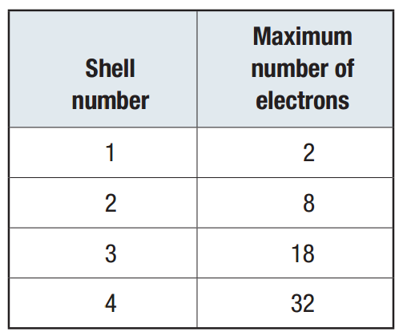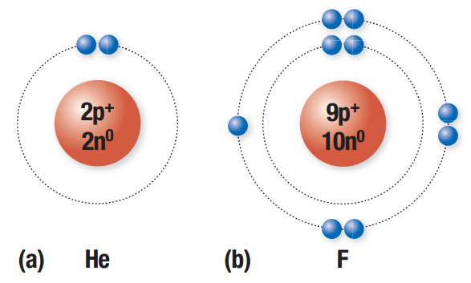

|  |  |  |  |
| --- | --- | --- | --- |
| Excited state: |  | Atomic number: |  |
| Mass number: |  |

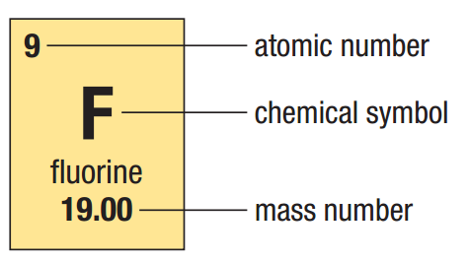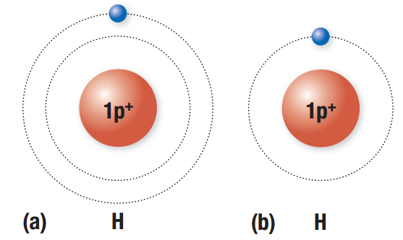

1. **Isotopes**

|  |  |
| --- | --- |
| Isotope: |  |

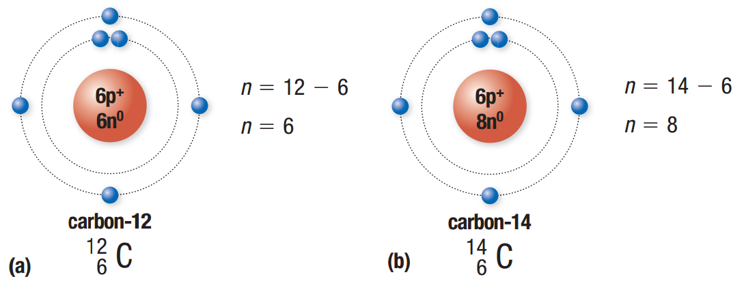

|  |  |
| --- | --- |
| Hydrogen: |  |
| deuterium |  |
| tritium |  |
| Periodic table: |  |

Draw the Bohr-Rutherford diagram for silicon-31.

1. **Medical applications of radioisotopes**

|  |  |
| --- | --- |
| Radioisotopes: |  |
| nuclear medical imaging |  |
| radionuclide therapy (RNT) |  |

**Homework:** page 322: #1-3, 5